**1. ABSTRACT**

Blood Source (BS) is a browser based system that is designed to store, process, retrieve and analyze information concerned with the administrative and inventory management within a blood bank. This project aims at maintaining all the information pertaining to blood donors, different blood groups available in each blood bank and helps them manage in a better way. Aim is to provide transparency in this field, make the process of obtaining blood from a blood bank hassle free and corruption free and make the system of blood bank management effective. Our client is not interested in blood stocking instead we are stocking blood donors information. The donors who are interested in donating blood has to register in the database. There is no storage of blood so no complications in the project. It is developed in a manner that is easily manageable, time saving and relieving one from manual works. The requirement of the blood has to be requested and we supply the information of the donor. The admin can update donor’s status whether they are available or not.

This Project is aimed to developing Online Blood Donation information. It presents a high-end system to bridge the gap between the blood donors and the people in need for blood. Through this application any person who is interested in donating the blood can register himself in the same way if any organization wants to register itself with this site that can also register. Moreover if any general consumer wants to make request blood online he can also take the help of this site. Admin is the main authority who can do addition, deletion, and modification if required

It is designed to automate the different operations in Blood Banks. Blood Source project makes it easy to give information regarding blood type, date of donation of blood, available blood group and many more. After the implementation of the project, the blood searching process is expected to be faster, easier, and reliable. Admin will view the donor side and view the available blood requested by the users. The numbers of persons who are in need of blood are increasing in large number day by day. In order to help people who are in need of blood, my Online Blood Bank can be used effectively for getting the details of blood donors having the same blood group and within the same city. With the help of my Online Blood Bank people who are having the thought of donating blood gets registered in my Online Blood Bank giving his total details

**2. INTRODUCTION**

**2.1 PROBLEM DEFINITION**

It helps in managing the blood bank available and also to manage the information of the user who is donating as well as requesting for the blood. The user consumes less amount of time. This project aims at maintaining all the information pertaining to blood donors, different blood groups available in each blood bank and helps them manage in a better way

**2.2SCOPE OF PROJECT**

The software maintains a record of each blood group. It helps the user to know whether the blood group which they search for is available or not. The information about eachuser is entered by the user and admin can retrieve the report of the user login and the donator.

* In this software the user has to fill the forms. Then the user can know the details of blood available.
* In computer system, it is not necessary to create the manifest but we can directly print it, which saves your time.
* To assist the staff in capturing the effort spent on their respective working areas.

**3. REQUIREMENTS**

**3.1 SOFTWARE REQUIREMENTS:**

|  |  |
| --- | --- |
| Front end | PHP |
| Back end | Microsoft SQL Server |
| Tools | Notepad, Visual Studio |
| Operating System | Windows 10 |
| Documentation | Microsoft Word 2010 |

**3.2 HARDWARE REQUIREMENTS:**

|  |  |
| --- | --- |
| Processor | Intel(R) Core(TM) i3-4005U CPU@ 1.70GHz |
| Ram | 4.00 GB |
| Free hard disk space | 370 MB (minimum install) |
| Monitor | VGA |
| CD_ROM_drive | 24X |

**4. SYSTEM ANALYSIS**

**4.1EXISTING SYSTEM**

The software to be produced is on **“Blood Source”**. There are 2 users that is, admin and user. User can register as a requestor of blood and admin can maintain the record of donors and requestors of blood.

**Demerits of Existing System**

* Lack of security of data.
* More man power.
* Time consuming.
* Consumes large volume of pare work.
* Needs manual calculations.
* No direct role for the higher officials.
* Damage of machines due to lack of attention.

**4.2. PROPOSED SYSTEM**

The disadvantages of the existing system have been solved by automating the **“Blood Source”** which acts as an interface between the donor and the receiver of blood. The user can register online with us as a donor or receiver and have a check on the availability of blood group of his requirement. The person who is eligible to donate can only donate blood.

**Advantages of Proposed System**

* It mainly eliminates the manual process which makes the task difficult.
* Saving time from going to blood bank and having a check of required blood we can directly register to the website any time anywhere and have a check on the blood of required group.
* Easy to retrieve the details of donor.
* Donating and requesting for the blood is made easy.

**Operational**

* Reduction of paper work.
* Human effort or Manual Labour can be reduced drastically.
* Major operations that are done manually can be done within a matter of seconds.
* Data storing is easier and backup is available.

**Economic**

* Annual Benefit is expected.
* Later, we add more features and increase our benefit.

**4.3. FEASIBILITY STUDY**

A feasibility study is an analysis of how successfully a project can be completed, accounting for factors that affect it such as economic, technological, legal and scheduling factors. A feasibility study tests the viability of an idea, a project or even a new business. The goal of a feasibility study is to place emphasis on potential problems that could occur if a project is pursued and determine if, after all significant factors are considered, the project should be pursued. Feasibility studies also allow a business to address where and how it will operate, potential obstacles, competition and the funding needed to get the business up and running.

Components of Feasibility study:

* Technical Feasibility
* Economic Feasibility
* Operational Feasibility
* Schedule Feasibility

**5. DETAILS OF SOFTWARE**

**5.1 OVERVIEW OF FRONT END**

**PHP Introduction**

PHP is a [general-purpose programming language](https://en.wikipedia.org/wiki/General-purpose_programming_language) originally designed for [web development](https://en.wikipedia.org/wiki/Web_development). It was originally created by [Ramus Lerdorf](https://en.wikipedia.org/wiki/Rasmus_Lerdorf) in 1994 the PHP [reference implementation](https://en.wikipedia.org/wiki/Reference_implementation) is now produced by The PHP Group. PHP originally stood for Personal Home Page, but it now stands for the [recursive initials](https://en.wikipedia.org/wiki/Recursive_initialism) PHP: Hypertext Preprocessor

The PHP code is written in HTML language for the development of “**BLOOD SOURCE”.** PHP is a server side scripting language. That is used to develop Static websites or Dynamic websites or Web applications. PHP stands for Hypertext Pre-processor, that earlier stood for Personal Home Pages. PHP scripts can only be interpreted on a server that has PHP installed. The client computers accessing the PHP scripts require a web browser only. A PHP file contains PHP tags and ends with the extension" php

**5.2 OVERVIEW OF BACK END**

**SQL Introduction**

SQL is a very powerful and diverse database language use to storing data into databases. SQL is loosely typed language so you can learn easily. In this SQL tutorial, we use command line examples to know about executing speed of SQL.

**“BLOOD SOURCE”** is developed by using sql server and Microsoft sql studio management for its backend connection. My SQL is a database management system that is used by Word Press to store and retrieve all your blog information. Think of it this way. If your database is a filing cabinet that Word Pressures to organize and store all the important data from your website (posts, pages, images, etc), then My SQL is the company that created this special type offering cabinet.

**6. SYSTEM DESIGN**

In the design phase the architecture is established. This phase starts with the requirement document delivered by the requirement phase and maps the requirements into architecture. The architecture defines the components, their interfaces and behavior. The deliverable design document is the architecture. The design document describes a plan to implement the requirements. This phase represents the “how” phase. Details on computer programming languages and environments, machines, packages, application architecture, distributed architecture layering, memory size, platform, algorithms, data structures, global type definitions, interfaces, and many other engineering details are established.

**Architectural design:**

The architectural design of a system emphasizes the design of the [system architecture](https://en.wikipedia.org/wiki/System_architecture) that describes the [structure](https://en.wikipedia.org/wiki/Structure), [behavior](https://en.wikipedia.org/wiki/Behavior) and more [views](https://en.wikipedia.org/wiki/View_model) of that system and analysis.

**Logical design:**

The logical design of a system pertains to an abstract representation of the data flows, inputs and outputs of the system. This is often conducted via modelling, using an over-abstract (and sometimes graphical) model of the actual system. In the context of systems, designs are included. Logical design includes [entity-relationship diagrams](https://en.wikipedia.org/wiki/Entity%E2%80%93relationship_model) (ER diagrams).

**Physical design:**

The physical design relates to the actual input and output processes of the system. This is explained in terms of how data is input into a system, how it is verified/authenticated, how it is processed, and how it is displayed.

**6.1 ER DIAGRAM**

An entity relationship diagram (ERD) shows the relationships of entity sets stored in a database. An entity in this context is a component of data. In other words, ER diagrams illustrate the logical structure of databases

An entity relationship diagram is a means of visualizing how the information a system produces is related. There are five main components of an ERD:

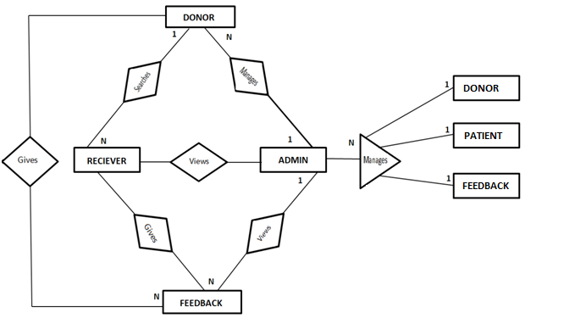

**6.2 DATA FLOW DIAGRAM (LEVEL 0 AND LEVEL 1)**

The Data Flow Diagrams (DFDs) are used for structure analysis and design. DFDs show the flow of data from external entities into the system. DFDs also show how the data moves and are transformed from one process to another, as well as its logical storage. The following symbols are used within DFDs. For clarity, a key has been provided at the bottom of this page.

A DFD shows what kind of information will be input to and output from the system, where the data will come from and go to, and where the data will be stored. It does not show information about the timing of process or information about whether processes will operate in sequence or in parallel.

**LEVEL 0:**

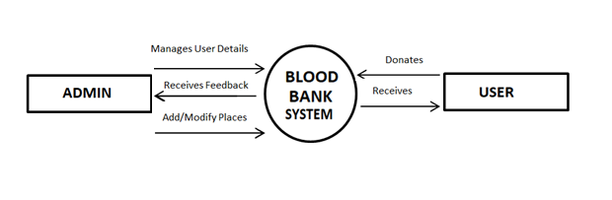

**LEVEL 1:**

**Donor:**

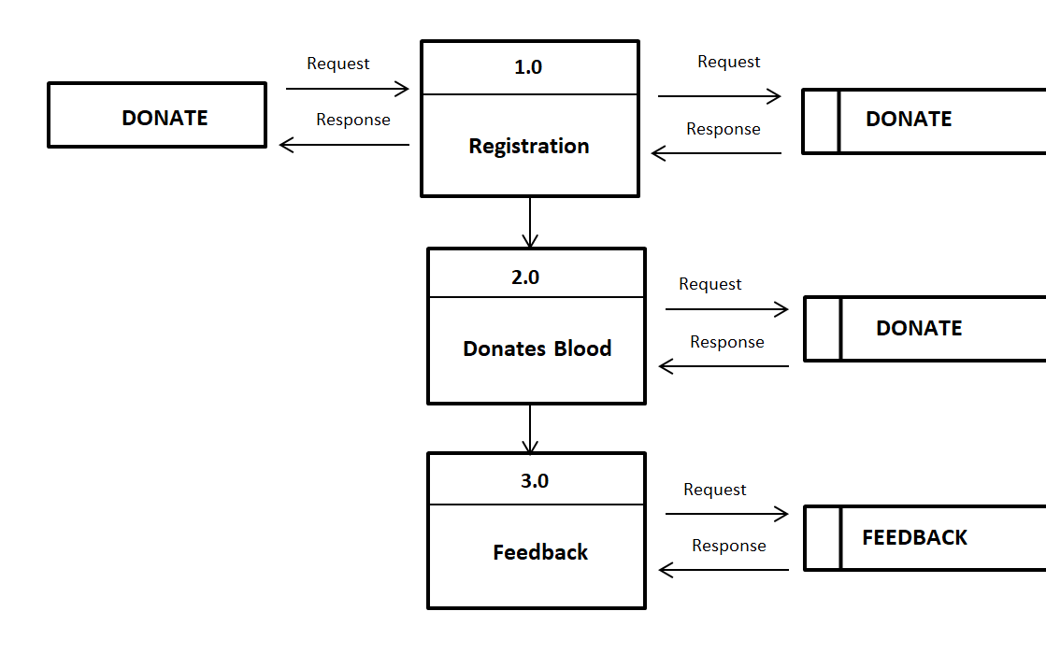

**Receiver:**

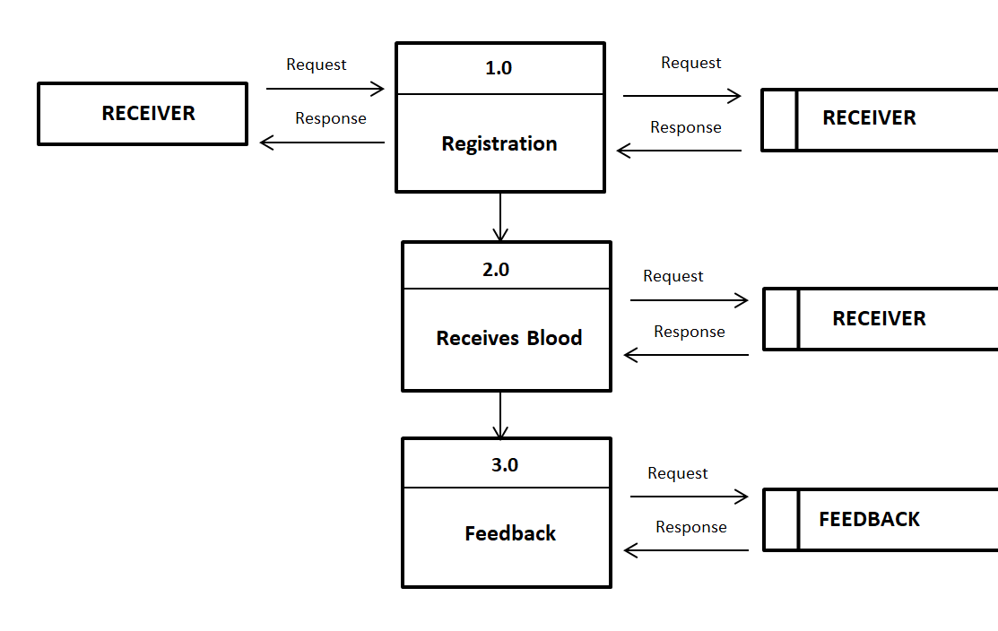

**Admin:**

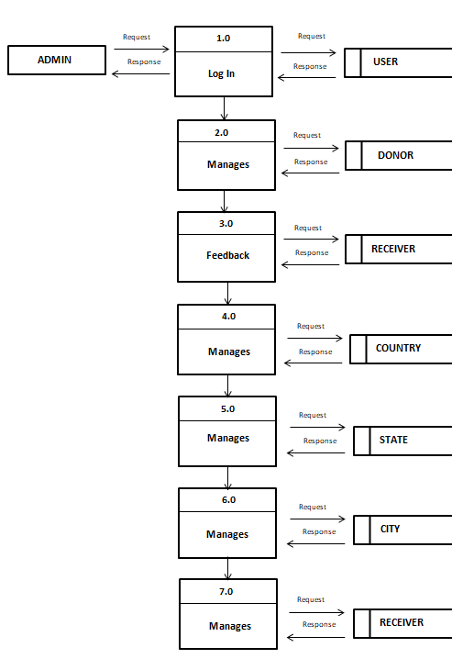

**7. SYSTEM IMPLEMENTATION**

**Screenshots:**

**Index Page**

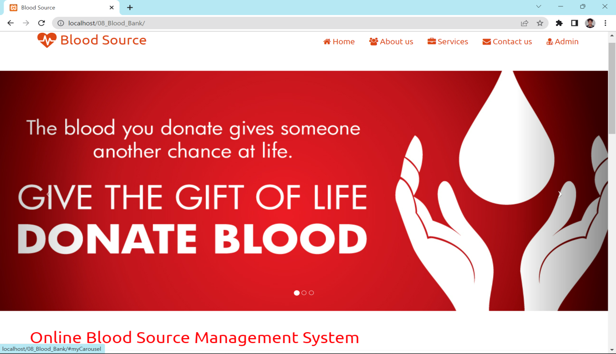

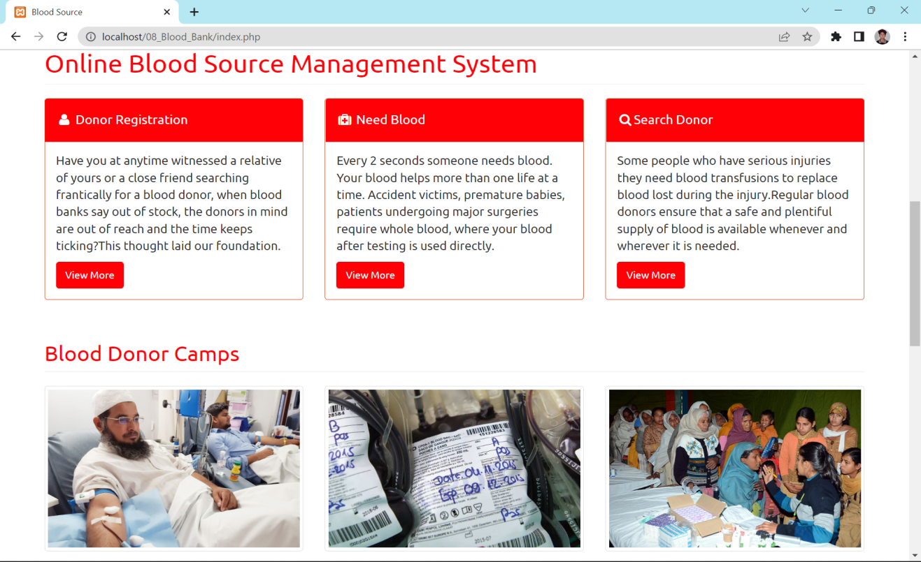

**Donor Registration:**

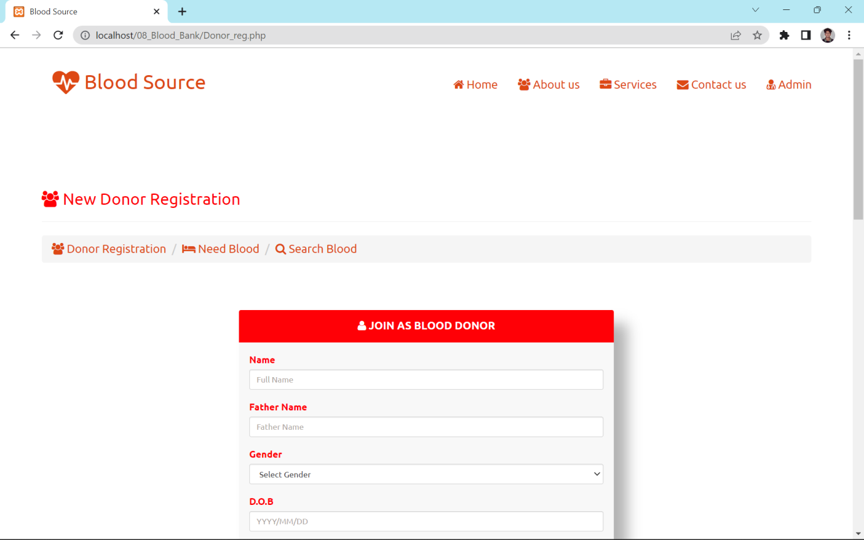

**Blood Request:**

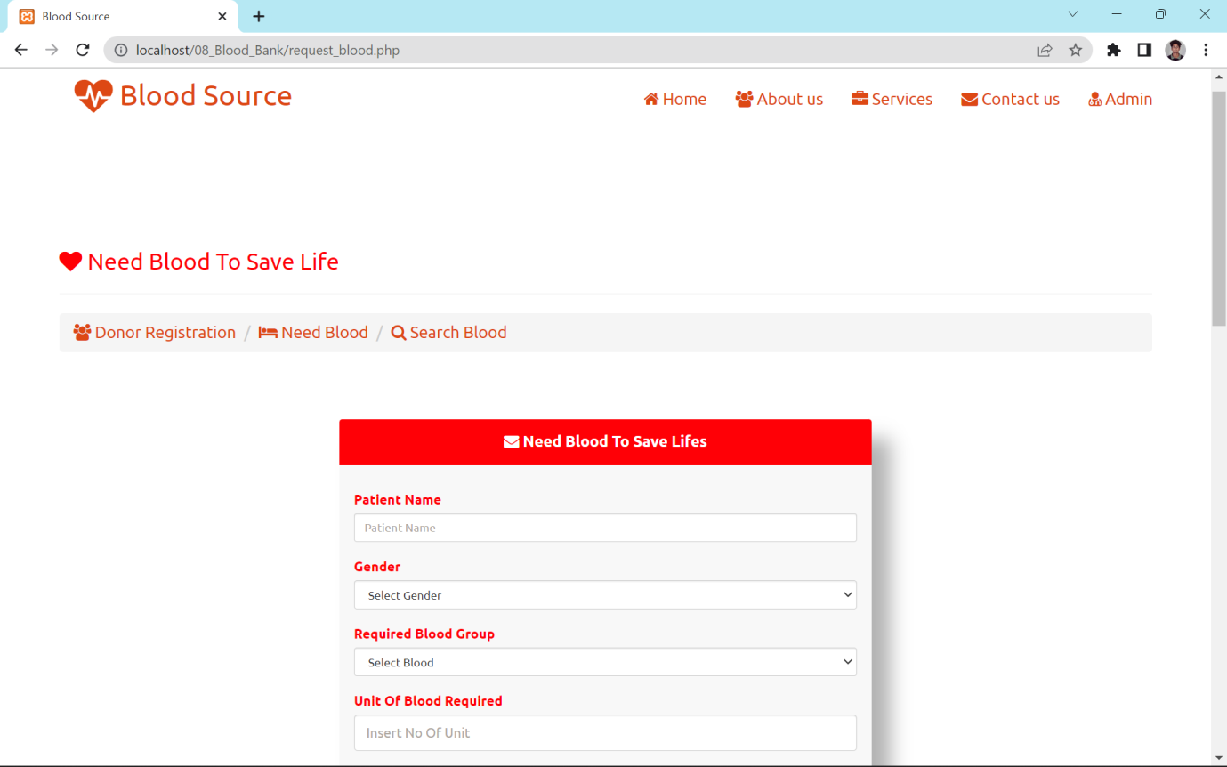

**Search Blood:**

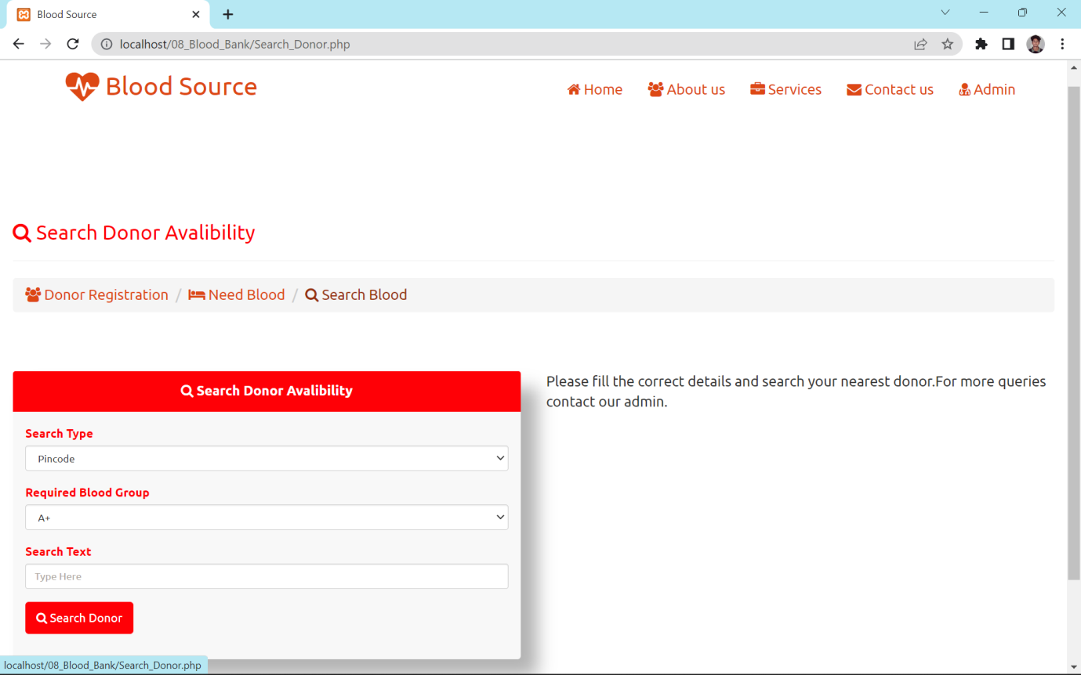

**Feedback:**

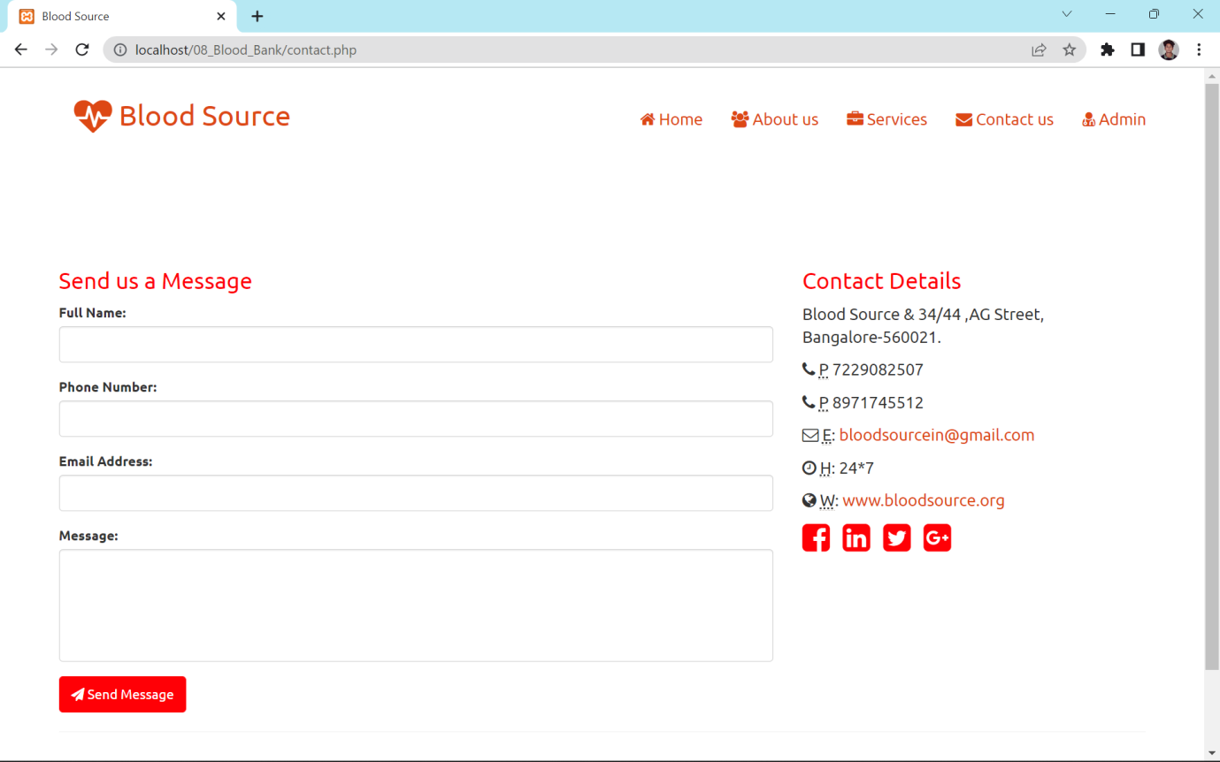

**Admin :**

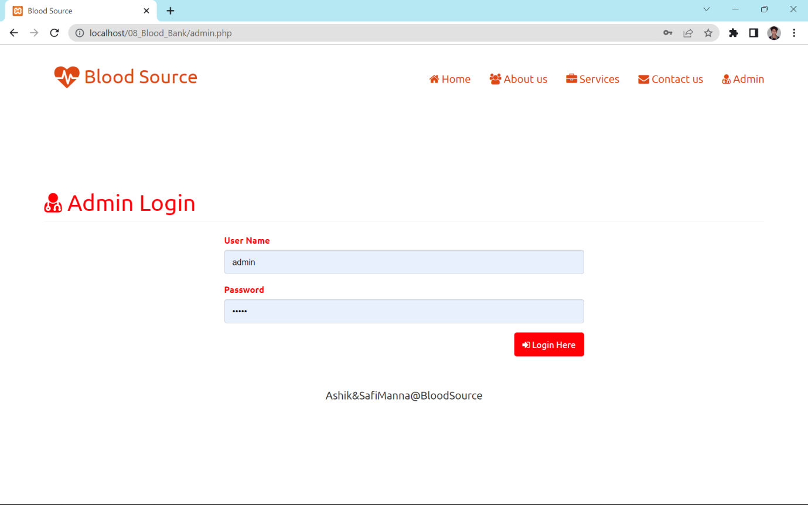

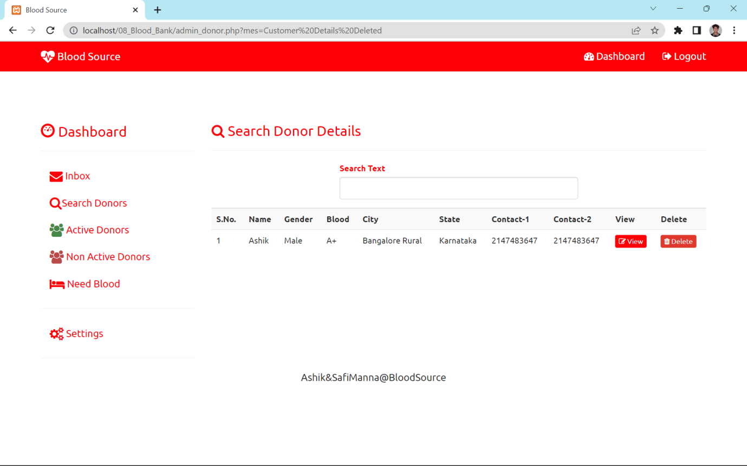

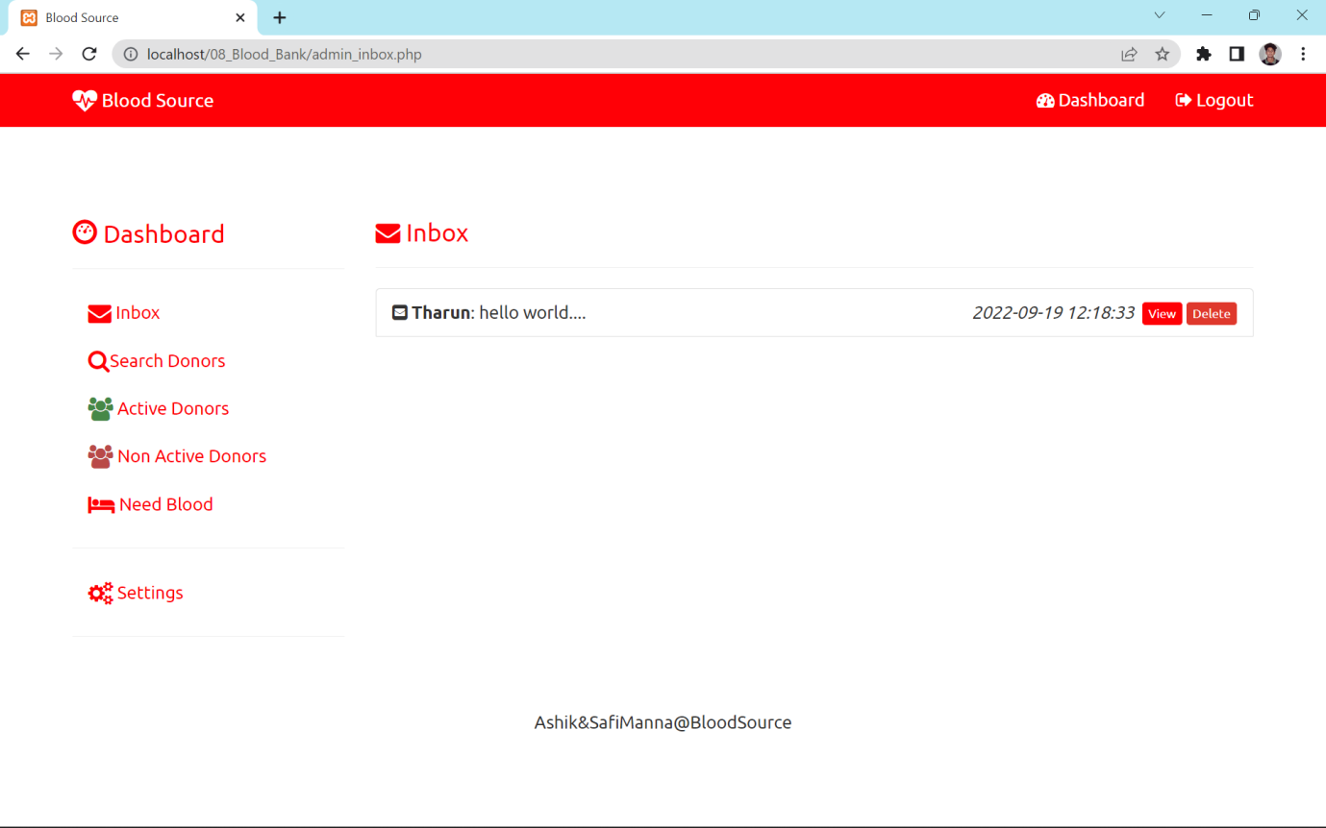

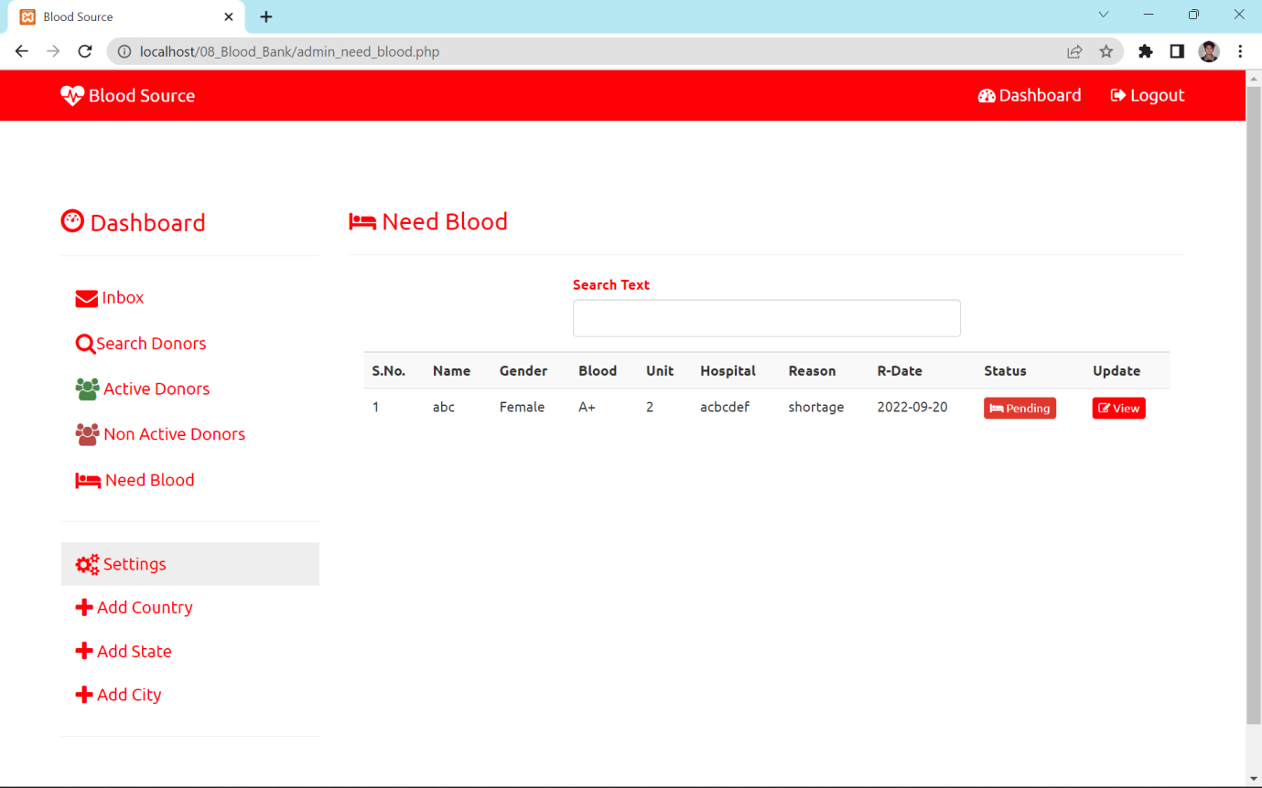

**8. CODE**

<!DOCTYPE html>

<html lang="en">

<?php include"head.php";?>

<body>

<?php include"top_nav.php";?>

<!-- Header Carousel -->

<header id="myCarousel" class="carousel slide">

<!-- Indicators -->

<ol class="carousel-indicators">

<li data-target="#myCarousel" data-slide-to="0" class="active"></li>

<li data-target="#myCarousel" data-slide-to="1"></li>

<li data-target="#myCarousel" data-slide-to="2"></li>

</ol>

<!-- Wrapper for slides -->

<div class="carousel-inner">

<div class="item active">

<div class="fill" style="background-image:url('images/s1.jpg');"></div>

<div class="carousel-caption">

</div>

</div>

<div class="item">

<div class="fill" style="background-image:url('images/s2.jpg');"></div>

<div class="carousel-caption">

</div>

</div>

<div class="item">

<div class="fill" style="background-image:url('images/s3.jpg');"></div>

<div class="carousel-caption">

</div>

</div>

</div>

<!-- Controls -->

<a class="left carousel-control" href="#myCarousel" data-slide="prev">

<span class="icon-prev"></span>

</a>

<a class="right carousel-control" href="#myCarousel" data-slide="next">

<span class="icon-next"></span>

</a>

</header>

<!-- Page Content -->

<div class="container">

<!-- Marketing Icons Section -->

<div class="row">

<div class="col-lg-12">

<h1 class="page-header text-primary">

Online Blood Bank Management System

</h1>

</div>

<div class="col-md-4">

<div class="panel panel-primary">

<div class="panel-heading">

<h4><i class="fa fa-fw fa-user"></i> Donor Registration</h4>

</div>

<div class="panel-body">

<p>Have you at anytime witnessed a relative of yours or a close friend searching frantically for a blood donor, when blood banks say out of stock, the donors in mind are out of reach and the time keeps ticking?This thought laid our foundation. </p>

<a href="Donor_reg.php" class="btn btn-primary">View More</a>

</div>

</div>

</div>

<div class="col-md-4">

<div class="panel panel-primary">

<div class="panel-heading">

<h4><i class="fa fa-fw fa-medkit"></i> Need Blood</h4>

</div>

<div class="panel-body">

<p>Every 2 seconds someone needs blood. Your blood helps more than one life at a time. Accident victims, premature babies, patients undergoing major surgeries require whole blood, where your blood after testing is used directly. </p>

<a href="request_blood.php" class="btn btn-primary">View More</a>

</div>

</div>

</div>

<div class="col-md-4">

<div class="panel panel-primary">

<div class="panel-heading">

<h4><i class="fa fa-fw fa-search"></i>Search Donor</h4>

</div>

<div class="panel-body">

<p>Some people who have serious injuries they need blood transfusions to replace blood lost during the injury.Regular blood donors ensure that a safe and plentiful supply of blood is available whenever and wherever it is needed.</p>

<a href="Search_Donor.php" class="btn btn-primary">View More</a>

</div>

</div>

</div>

</div>

<!-- /.row -->

<!-- Portfolio Section -->

<div class="row">

<div class="col-lg-12">

<h2 class="page-header text-primary">Blood Donor Camps</h2>

</div>

<div class="col-md-4 col-sm-6">

<a href="#">

<img class="img-responsive img-portfolio img-thumbnail img-hover" src="images/p1.jpg" alt="">

</a>

</div>

<div class="col-md-4 col-sm-6">

<a href="#">

<img class="img-responsive img-portfolio img-thumbnail img-hover" src="images/p2.jpg" alt="">

</a>

</div>

<div class="col-md-4 col-sm-6">

<a href="#">

<img class="img-responsive img-portfolio img-thumbnail img-hover" src="images/p3.jpg" alt="">

</a>

</div>

<div class="col-md-4 col-sm-6">

<a href="#">

<img class="img-responsive img-portfolio img-thumbnail img-hover" src="images/p4.jpg" alt="">

</a>

</div>

<div class="col-md-4 col-sm-6">

<a href="#">

<img class="img-responsive img-portfolio img-thumbnail img-hover" src="images/p5.jpg" alt="">

</a>

</div>

<div class="col-md-4 col-sm-6">

<a href="#">

<img class="img-responsive img-portfolio img-thumbnail img-hover" src="images/p6.jpg" alt="">

</a>

</div>

</div>

<!-- /.row -->

<!-- Features Section -->

<div class="row">

<div class="col-lg-12">

<h2 class="page-header text-primary">Why we need you to give blood ?</h2>

</div>

<div class="col-md-6">

<ul>

<li>Giving blood saves lives. The blood you give is a lifeline in an emergency and for people who need long-term treatments.</li>

<li>Many people would not be alive today if donors had not generously given their blood.</li>

<li>We need over 6,000 blood donations every day to treat patients in need across india. Which is why there’s always a need for people to give blood.</li>

<li>Each year we need approximately 200,000 new donors, as some donors can no longer give blood.</li>

<li>Most people between the ages of 17-65 are able to give blood.</li>

<li>Around half our current donors are over 45. That's why we need more young people (over the age of 17) to start giving blood, so we can make sure we have enough blood in the future.</li>

</ul>

</div>

<div class="col-md-6">

<img class="img-responsive" src="images/contact.jpg" alt="">

</div>

</div>

<!-- /.row -->

<hr>

<!-- Call to Action Section -->

<div class="well">

<div class="row">

<div class="col-md-8">

<p>We expect your loyal feedback to improve our standard.For more details and any subject related queries..</p>

</div>

<div class="col-md-4">

<a class="btn btn-primary btn-block" href="contact.php"><i class="fa fa-phone"></i> Call to Action</a>

</div>

</div>

</div>

<div class="modal fade" id="myModal">

<div class="modal-dialog">

<div class="modal-content">

<img src='' width="100%" height="100%" id='ModalImg'>

</div>

</div>

</div>

<hr>

<!-- Footer -->

<?php include"footer.php"; ?>

</div>

<!-- /.container -->

<!-- jQuery -->

<script src="js/jquery.js"></script>

<!-- Bootstrap Core JavaScript -->

<script src="js/bootstrap.min.js"></script>

<!-- Script to Activate the Carousel -->

<script>

$('.carousel').carousel({

interval: 5000 //changes the speed

})

$(".img-portfolio").click(function(){

var a=$(this).attr("src");

$("#ModalImg").attr("src",a);

$('#myModal').modal();

})

</script>

</body>

</html>

echo "<div class='alert alert-success fade in' ><a href='#' class='close' data-dismiss='alert' aria-label='close'>&times;</a><strong>Information : </strong>Your Blood request is sent. Admin will contact you soon</div>";

}

else

{

echo "<div class='alert alert-danger fade in' ><a href='#' class='close' data-dismiss='alert' aria-label='close'>&times;</a><strong>Error : </strong>Server busy.Try again later.</div>";

<form autocomplete="off" method="post" action="<?php echo $_SERVER['PHP_SELF'];?>" enctype="multipart/form-data">

<div class="form-group">

<label class="control-label text-primary">Patient Name</label>

<input type="text" placeholder="Patient Name" name="NAME" required id="NAME" class="form-control input-sm">

</div>

<div class="form-group">

<label class="control-label text-primary" for="GENDER">Gender</label>

<select id="gen" name="GENDER" required class="form-control input-sm">

<option value="">Select Gender</option>

<option value="Male">Male</option>

<option value="Female">Female</option>

<option value="Thirunangai">Thirunangai</option>

<option value="Thirunambi">Thirunambi</option>

</select>

</div>

<div class="form-group">

<label class="control-label text-primary">Required Blood Group</label>

<select name="BLOOD" id="BLOOD" required class="form-control input-sm">

<div class="form-group">

<label class="control-label text-primary">Need Unit Of Blood</label>

<input type="text" required name="BUNIT" id="BUNIT" class="form-control" placeholder="Insert No Of Unit">

</div>

<div class="form-group">

<label class="control-label text-primary">Hospital Name &amp; Address</label>

<textarea required name="HOSP" id="HOSP" rows="5" style="resize:none;"class="form-control" placeholder="Hospital Full Address"></textarea>

</div>

<div class="form-group">

<label class="control-label text-primary">City</label>

<input type="text" required name="CITY" id="CITY" class="form-control" placeholder="Insert City">

</div>

<div class="form-group">

<label class="control-label text-primary">Pincode</label>

<input type="text" required name="PIN" id="PIN" class="form-control" placeholder="Insert Pincode">

</div>

<div class="form-group">

<label class="control-label text-primary">Doctor Name</label>

<input type="text" placeholder="Doctor Name" class="form-control input-sm" name="DOC" id="DOC">

</div>

<div class="form-group">

<label class="control-label text-primary">When Required</label>

<input type="text" placeholder="MM/DD/YYYY" class="form-control input-sm DATES" name="RDATE" id="RDATE">

</div>

<div class="form-group">

<label class="control-label text-primary">Contact Name</label>

<input type="text" placeholder="Contact Name" class="form-control input-sm" name="CNAME" id="CNAME">

</div>

<div class="form-group">

<label class="control-label text-primary">Address</label>

<textarea required name="CADDRESS" id="CADDRESS" rows="5" style="resize:none;"class="form-control" placeholder="Full Address"></textarea>

</div>

<div class="form-group">

<label class="control-label text-primary">Email ID</label>

<input type="text" placeholder="Contact Email" class="form-control input-sm" name="EMAIL" id="EMAIL">

</div>

$("#BTN").click(function(){

var NAME=$("#NAME").val();

var BLOOD=$("#BLOOD").val();

var BUNIT=$("#BUNIT").val();

var HOSP=$("#HOSP").val();

var CITY=$("#CITY").val();

var PIN=$("#PIN").val();

var DOC=$("#DOC").val();

var RDATE=$("#RDATE").val();

var CNAME=$("#CNAME").val();

var EMAIL=$("#EMAIL").val();

var CON1=$("#CON1").val();

var CON2=$("#CON2").val();

var REASON=$("#REASON").val();

var PIC=$("#PIC").val();

if($("#NAME").val() == "" )

$("#errorBox").html("<div class='alert alert-danger fade in' ><a href='#' class='close' data-dismiss='alert' aria-label='close'>&times;</a><strong>Warning : </strong> Unit should be numeric.</div>");

return false;

}

**9. TESTING PHASE**

Software testing is the crucial elements of the software quality assurance and represents the ultimate review of specification, design and coding. Testing represents an interesting anomaly for the software. During earlier definition and development phase, it was attempted to build software from an abstract concept to tangible information. The testing phase is a very important phase since it is in this phase; we make sure that the system will perform the task without any error. Testing is vital to the success of the system and is being done by classifying it in two ways system testing and program testing. Program testing involves checking the syntax and logic of the program. This checking resulted in achieving error free program.

Testing methods

1. Unit testing
2. Output testing
3. Integration testing

**Unit testing**

Unit testing focusesverification efforts on the smallest unit of softwaredesign, the module. This also known as “Module Testing”. The module is tested separately. This testing is carried out during programming stage itself. In these testing steps each module is found to be found to be working satisfactorily as regard to the expected output from the module. All the modules of our project has undergone unit testing. Registration Module, Donator Module, Receiver Module, View Blood Stock Module, Previous Transaction Module, Approval of Donor and Receiver Request by the Admin and upgrade Blood Stock Module, each unit of these modules has been tested individually and is verified.

**Output testing**

After performing the validation testing, the next step is output testing of the proposed system could be useful if it does not produce the required output in the specified format. The output generated or displayed by them. Here, the output is considered into two ways: one is on the screen and the other is printed format. Registration module, update module, admin module, approval of blood request and donation module have undergone this testing, by producing the appropriate output on the screen.

**Integration testing**

The different modules are integrated as per the system design. The different modules are combined into subsystem and then tested to detect errors. The goal of the integration testing is to see if the modules can be integrated properly. It also involves interface testing. Registration module, blood request module, blood stock module have undergone integration testing . The Previous Transaction Module of the User is based on whether the request of donor and receiver is approved by the Admin. In that case the previous transaction module will showcase the history of the user based on their Donation and Request for blood, without interrupting the working of other modules

**Validation Testing**

The process of evaluating software during the development process or at the end of the development process to determine whether it satisfies specified business requirements. Validation Testing ensures that the product actually meets the client's needs. It can also be defined as to demonstrate that the product fulfills its intended use when deployed on appropriate environment. All the registration modules in our project has undergone validation testing. Registration Module- Phone number Validation is done as the Textbox cannot accept string values and should have a maximum length of 10 digits, Password should contain the maximum length of 9 Characters (string,number,special Characters) .Email. Name, Gender & Address fields cannot be Null.

User Donation Module contains BMI validation with respect to weight and height of the user specified during Registration.

In Receiver Module and Donation Module the value of Quantiy should be specified in Numeric and cannot accept String.

**9.1 SAMPLE REPORT OF TEST CASES**

|  |  |  |  |  |  |  |  |
| --- | --- | --- | --- | --- | --- | --- | --- |
| **Sl no.** | **Test Id** | **Test Description** | **Steps to execute** | **Test data** | **Expected result** | **Actual result** | **Status** |
| **1** | TC _LF_ 1.0  Field level validation. | To verify whether the field is filled. | Enter the username & password in appropriate fields then click login | kjc  423 | System should accept the data & login into the account else error message is shown | Username & password details are accepted | Pass |
| **2** | TC _BS_ 2.0  Search criteria validation. | To verify wether the blood in database visible as output | Select the Blood group & then click check_details | B+ | System should accept the Blood group and search for desired data. | System accepts the Blood goup & searches for the data & displays it. | Pass |
| **3** | TC _Rf_ 3.0  Saving data Validation. | Test wether the data entered in form is registered in the database. | Enter the appropriate details in the field. | Ammu  Female  18  741180751  1254 | System should accept the data entered by the user and save it in the database. | System accepts the data and saves it in database. | Pass |
| **4** | TC_RS_4.0  Form level validation. | Test wether the data entered in the base is displayed in the graph format. | Fills the details and produce with the next form | Response.Redirect  (form3.show) | System should display the data of the selected field | System accepts the selected value& profit_or_loss &display the graph. | Pass |
| **5** | TC_RV_5.0  Range Validation | To test wether the data entered contains only 10 digits enter according to the web format . | Enter the phone number | 74111810751 | When the button is clicked it check the format if the nuber exceed more than 10, it does not accept. | System accepts the entered phone number. | Pass |
| **6** | TC_MI_6.0  Masked Input Validation. | To hide the password given by the user. | Enter the password. | ***** | The password entered is masked. | System accepts the password and it is masked. | Pass |

**10. TABLE STRUCTURE**

**Donor Registration:**

|  |  |  |
| --- | --- | --- |
| **Name** | **Data Type** | **Null** |
| Donor_id | Int(11) | Primary Key |
| Name | Varchar(100) | No |
| Father_Name | Varchar(100) | No |
| Gender | Varchar(100) | No |
| DOB | Date | No |
| Blood | Varchar(100) | No |
| Body weight | Int(11) | No |
| Email | Varchar(100) | No |
| Address | Varchar(100) | No |
| City | Varchar(100) | No |
| Pincode | Int(100) | No |
| State | Varchar(100) | No |
| Country | Varchar(100) | No |
| Contact1 | Int(10) | No |
| Contact2 | Int(10) | No |
| Voluntary | Varchar(100) | No |
| Donor_pic | Varchar(100) | No |
| Status | Int(11) | No |

**Blood Request:**

|  |  |  |
| --- | --- | --- |
| **Name** | **Data Type** | **Null** |
| ID | Int(11) | Primary Key |
| Name | Varchar(100) | No |
| Gender | Varchar(100) | No |
| Blood | Varchar(100) | No |
| Bood_Unit | Int(10) | No |
| Hospital | Varchar(100) | No |
| City | Varchar(100) | No |
| Pin | Int(100) | No |
| Doctor_name | Varchar(100) | No |
| R_Date(req) | Date | No |
| CName | Varchar(100) | No |
| CAdress | Varchar(100) | No |
| Email | Varchar(100) | No |
| Contact1 | Int(10) | No |
| Contact2 | (10) | No |
| Reason | Varchar(100) | No |
| Pic | Varchar(100) | No |
| Status | Varchar(100) | No |
| Cdate | Date | No |

**City:**

|  |  |  |
| --- | --- | --- |
| **Name** | **Data Type** | **Null** |
| City_Id | Int(11) | Primary Key |
| State_Id | Int(11) | No |
| City_Name | Varchar(100) | No |

**Country:**

|  |  |  |
| --- | --- | --- |
| **Name** | **Data Type** | **Null** |
| Country_id | Int(11) | Primary Key |
| Country_Name | Varchar(100) | No |

**Message:**

|  |  |  |
| --- | --- | --- |
| **Name** | **Data Type** | **Null** |
| Id | Int(11) | Primary Key |
| Name | Varchar(100) | No |
| Contact | Int(11) | No |
| Email | Varchar(100) | No |
| Message | Text | No |
| Status | Text | No |
| logs | datetime | No |

**State:**

|  |  |  |
| --- | --- | --- |
| **Name** | **Data Type** | **Null** |
| State_Id | Int(11) | Primary Key |
| State_Name | Varchar(100) | No |
| Country | Varchar(100) | No |

**11. CONCLUSION**

To conclude the description about the project the project, developed using Vb.net and SQL SERVER is based on the requirement specification of the user and the analysis of the existing system, with flexibility for future enhancement.

The project was successfully completed within the time span allotted. Every effort has been made to present the system in more users–friendly manner. All the activities provide a feeling like an easy walk over to the user who is interfacing with the system. All the disadvantages of the existing system have been overcome using the present system of “Blood bank management system” which has been successfully implemented at client’s location. A trial run of the system has been made and is giving good results.

Blood Bank Manager helps you manage your processes. A Blood Bank Manager provides all process management tool elements: modeling, analysis, and simulation. Documentation though an important part of a blood bank management, is a non-productive exercise for the intellectual human being, whose ability lies in core areas of excellence. Hence a systematic approach to the way documents is managed, can transform your pharmacy retailing resources to its highest utility and advantage.

**12. FUTURE ENHANCEMENT**

The system has been developed using the present scenario language Microsoft Visual Basic C# as its front end tool and Microsoft SQL Server 2012 as its backend. All the modules are tested separately and put together to form the main system. Finally the system is tested with real data and everything worked successfully.

The present Blood Bank project may be further developed for more complex transactions and to meet the requirements of modern-day dynamic System Operation New options and their respective implementation may be done for this purpose.

Thus the system has fulfilled the entire objective identified. The system has been developed in an attractive dialogs fashion and the entire user interface is attractive and user friendly and suits all the necessities laid down by the clients initially. So user with minimum knowledge about the computers and the system can easily work with the system.

* The Admin can have access to view the reports.
* The participant can be provided with the user login